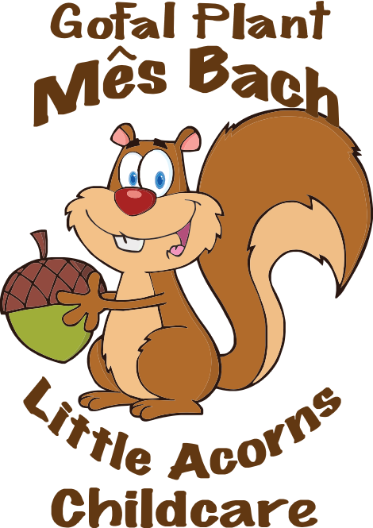

Statement of purpose (information about our provision)
Mes Bach-Little Acorns aims to:
- Provide high quality day care that enhances the development, care and education of pre-school children in a safe and stimulating environment, where they learn through play in partnership with parents

- Welcome parents who want to become directly involved in the activities of the provision and provide opportunities to do so

- Encourage parents to understand and provide for the needs of their children

- Embrace the ethos and principles of Wales Pre-school Providers Association.
Mes Bach follows Welsh Government initiatives by implementing The Foundation Phase, Flying Start, Helping Hands, Design to Smile, Busy feet and the Healthy Pre-school Scheme.
We are proud of our quality assurance status (say what this is).
Mes Bach-Little Acorns is managed by a voluntary committee as a registered charity and is registered by Care and Social Services Inspectorate Wales (CSSIW) under part 2 of the Children and Families (Wales) measure 2010 and The Regulation of Child Minding and Day Care (Wales) Order 2016 to provide day care as an unincorporated organisation.
The responsible individual is:
The person in charge on a day to day basis is: Angharad Rennie-Davies
The committee officers are: Chair person: Anna Mostyn
Vice Chair: Leon Gobourn
Secretary:
Treasurer: Mark Longman

Mes Bach welcomes boys and girls and is registered by CSSIW to care for a total of 44 children from 2 - 4 years we care for up to 20 children, 3 - 12 years for up to 40 children.
We meet children’s needs as individuals and within groups as a provider of full day care and out of school care.
Our latest inspection report by CSSIW can be seen on www.cssiw.org.uk and the latest inspection report by Estyn can be seen on www.estyn.gov.uk
Mes Bach is covered by public liability and employer’s liability insurance. Certificates are displayed foyer.
Operational hours: We are open Monday – Friday each week 8.00am – 6.00pm during term time only. See our admissions policy for details about how we manage applications to our service.
Staff are recruited, employed within and work to or exceed, regulatory requirements at all times. We have a ratio of one adult to four children aged 2 years and one adult to eight children aged 3 - 4 years within the Nursery, one adult to eight children 3 - 12 year within the After School and Holiday club. Mes Bach welcomes students on placement, volunteers and visitors who enrich the experiences of children.
Facilities available: Mes Bach operates in a purpose built premises with different indoor play space and learning areas, toilet facilities, kitchen, staff rest area, outdoor play space, storage, and an office.
Services offered include collection from the local primary school Comins Coch and snacks and drinks offered throughout the day in line with our healthy eating policy. Water is always available for children to drink. Children’s individual needs and preferences are noted and recorded as they register to join the provision. Parents must complete a contract and are encouraged to use our ‘settling in’ service to help with their child’s transition to our care.
Activities offered are from a wide range that are planned to suit children’s age, stage and individual needs and meet our aims and objectives and reflect Welsh Government current strategy.
We provide adult-led and child-led experiences that are planned weekly in advance.
Activities are risk assessed and children are encouraged to contribute to any review or evaluation of their experiences as they are able and willing.

Sample of a typical day’s routine:
8.00am | 8.30am | 9.15am | 9.30am | 10.00am | 10.30am | 11.15am | 11.30am | 11.45am
Breakfast | Free play and settling in time | Tidy up, toileting, hand wash | Story time and registration | Snack time | Focus task | Tidy up | Design to smile | Singing and home time

12.00pm | 12.15pm | 12.30pm | 1.00pm | 1.30pm | 2.00pm | 2.15pm | 2.45pm | 3.15pm
Toileting, wash hands | Lunch | Free play | Registration/ mat time | Design to Smile/ Free play | Focus task | Free play | Toileting, wash hands and snack time | Singing and home time

There are no animals kept on the premises.
The language used: Mes Bach is an English service and Welsh taught as a second language.

Parental involvement: Wales PPA believes that parents are the prime carers and educators of their children and as such should be involved in all aspects of the provision. As a member of Wales PPA, Mes Bach welcomes parents who would like to become involved in:
- Assisting with the management of the provision.

- Working in the provision on a rota basis.

- Fundraising.

- Representing the provision on Wales PPA Board of Trustees

- Attending relevant training courses, workshops, and conferences.

Training: we have a system in place to ensure that regulatory training in food hygiene, paediatric first aid and child protection is maintained. Our membership of Wales PPA ensures that we are kept up-to-date with current developments and initiatives in the field of childcare and education. We receive smalltalk, Wales PPA’s magazine, which offers practical advice and up-to-date information, and we are happy to share this with parents. The provision also has access to other publications from Wales PPA. We have signed up to the CSSIW website and receive news regularly about any changes or information about regulated settings.
Mes Bach works with the support of Wales PPA to invest in our staff’s commitment to their continuous professional development through reliably endorsed courses, regional meetings, events and training pathways, and parents are kept informed about these.

Fees (see also: admissions policy): Fees are payable by the session/day and are paid monthly- in advance by cash, cheque, and vouchers.
Fees are payable if a child is absent without notice or for a short period of sickness/family holiday.
Parents are advised to speak to Angharad Rennie-Davies about payment of fees in cases of prolonged absence.

A child's continued place at Mes Bach is dependent on continued payment of fees.

Starting in the provision: Mes Bach acknowledges the importance of parents and staff working together to help children settle in to our care and develop confidence to participate in all the activities offered. Some children take longer than others to settle. The treatment of each child as an individual is our main concern. Parents may stay for the whole or part of the session, depending on the needs of their child (please see our settling-in policy).

Observations, assessment and record keeping: Mes Bach’s staff take a reflective approach to their work, using observation as a tool to plan activities and ensure children’s needs are met. The progress of children is assessed by observation and recorded. Mes Bach has a duty to share some information with the local authority and CSSIW. Our records are available for discussion with parents at any time and are kept in line with our confidentiality policy.
The terms and conditions are set out in the contract between parents and Mes Bach and are implicit within our policies and procedures.
The contract must be signed and the registration form must be completed by parents before their child attends.

Policies and procedures: we have produced a pack of policies and procedures that describe arrangements for dealing with routine operational practice, complaints, concerns, and any emergency that may occur during operational hours. They are designed to ensure effective and safe management of our service and to offer the best possible environment and experience for the children and families who use it. The policies and procedures are developed and maintained in line with and/or exceed national minimum standards and regulations. They are reviewed regularly (at least annually) and updated (and CSSIW informed of any significant changes) as necessary. The policy pack is available for all who visit, work in or use Mes Bach to see. It is kept in the foyer.
Arrangements for dealing with complaints and concerns: we welcome comments from parents and aim to resolve any concerns quickly. Please speak to or make a complanit in writing to Angharad Rennie-Davies at any time, you can contact CSSIW about a registered service at:
CSSIW
South West Region
Government Buildings
Picton Terrace
Carmarthen
SA31 3BT Tel: 03007900126
We also have a suggestions box in our foyer and older children have their own in their room, on the table on the left after the coat hooks.
Arrangements for dealing with emergencies: our staff are trained in paediatric first aid and we have procedures in place for keeping your child safe while in our care. Our contract ensures that we keep all contact details for parents up to date. We carry out risk assessments on activities and the premises and maintain a log of emergency evacuation drills.
Samples of the contract, registration form and the full set of policies and procedures are available from Angharad Rennie-Davies.
This statement of purpose is reviewed at least annually or as a result of a change in operational practice. Parents are informed of any changes as they occur and CSSIW is informed of any changes within 28 days.

This statement of purpose for Mes Bach was passed for use
On: April 2017
By: Angharad Rennie-Davies Position: Manager
Date of planned review: 2018 Date CSSIW informed of change:

